Comprehensive project

Shuvo

**BUSSINESS CENTER**

**Course name : Computer fundamental & office application**

**Name: Mamun Mia**

**Batch No: 38**

**Roll no : 08**

**Date :04-12-2024**

Table of Contents

**Name:** 3

**Industry:** 3

**Founded:** 3

1.Mission 3

1 Product Range: 3

Target Market 3

Sustainability Commitment 3

Sales Channels: 3

Achievements: 3

2 2.PRODUCTS: 3

2.1 Phones 4

2.2 Laptops 4

2.3 Speakers 5

2.4 Televisions 6

3 .Overview of Services 7

4 .Business plan: 8

5 .Salaes and cost statics: 9

**Company Overview**

**Name:** Shuvo business center

**Industry:** Sales and services of electronics product

**Founded:** 2024

1.Mission**:** To enhance the digital experience by providing innovative, high-quality electronic accessories that empower users in their daily lives.

# Product Range:

* **Smart phone**
* **Laptop**
* **Speaker**
* **Smart tv**

Target Market**:** Tech-savvy consumers, students, professionals, and families looking for reliable and stylish accessories to complement their devices.

Sustainability Commitment**:** Focus on eco-friendly materials and packaging, as well as a recycling program for old electronics.

Sales Channels: Online store, major e-commerce platforms, and select retail partnerships.

Achievements: Recognized for exceptional customer service and innovation, with several awards for product design and sustainability initiatives.

# 2.PRODUCTS:

**Here are product ideas for each of the categories phone, laptop, speaker, and television.**

## Phones

* **Smartphones**
  + **High-End Models**: Flagship devices with top-tier specs, including advanced cameras and high refresh rate displays.
  + **Mid-Range Phones**: Affordable options with solid performance and features like good battery life and decent cameras.
  + **Rugged Phones**: Durable smartphones designed for extreme conditions, water, and dust resistance.
  + **Foldable Phones**: Innovative designs that allow screens to fold for portability.

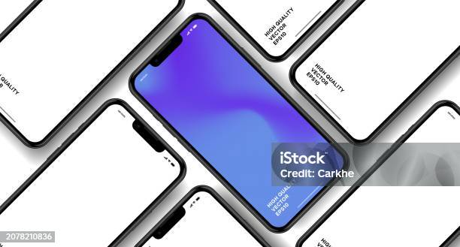

## Laptops

* **Ultrabooks**
  + **Lightweight Models**: Slim, portable laptops with long battery life for professionals and students.
  + **2-in-1 Laptops**: Devices that can function as both a laptop and a tablet with touchscreens.
* **Gaming Laptops**
  + **High-Performance Models**: Equipped with powerful GPUs, fast refresh rate displays, and advanced cooling systems.
* **Business Laptops**
  + **Secure and Durable Models**: Laptops with enhanced security features and rugged designs for business use.
* **Budget Laptops**
  + **Entry-Level Options**: Affordable devices for basic tasks like web browsing and word processing.

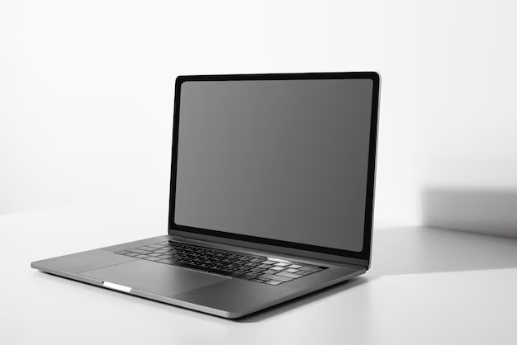

## Speakers

* **Portable Bluetooth Speakers**
  + **Waterproof Models**: Ideal for outdoor use with durable designs.
  + **Multi-Room Systems**: Speakers that can be linked for a surround sound experience throughout the home.
* **Smart Speakers**
  + **Voice-Activated Models**: Equipped with virtual assistants (like Alexa or Google Assistant) for hands-free control.
  + **High-Fidelity Speakers**: Premium audio quality for audiophiles, often with Wi-Fi streaming capabilities.
* **Soundbars**
  + **Surround Sound Soundbars**: Designed to enhance home theater experiences with multi-channel audio.
  + **Compact Models**: Space-saving designs that still provide rich sound quality.

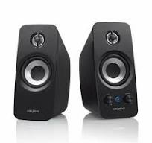

## Televisions

* **Smart TVs**
  + **4K Ultra HD TVs**: High-resolution displays for stunning visuals, often with HDR support.
  + **OLED TVs**: Offering superior contrast and color accuracy for the best viewing experience.
* **Budget Smart TVs**
  + **Affordable Options**: TVs with essential smart features and decent picture quality for value-conscious consumers.
* **Gaming TVs**
  + **Low Input Lag Models**: Specifically designed for console gaming, with features like variable refresh rates.

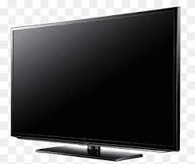

# .Overview of Services

#### 1. Smartphones

* **Repair Services**: Screen replacements, battery issues, software updates.
* **Accessories**: Cases, chargers, screen protectors.
* **Customization**: Personalization of settings, themes, and apps.

#### . Laptops

* **Technical Support**: Troubleshooting, malware removal, system optimization.
* **Upgrades**: RAM, SSD, and software upgrades.
* **Refurbished Sales**: Quality checked laptops at discounted price

#### Speakers

* **Installation Services**: Setting up home audio systems.
* **Bluetooth Pairing**: Assistance with connectivity issues.
* **Sound Quality Tuning**: Optimizing audio settings for best performance.

#### TVs

* **Mounting Services**: Wall mounting and cable management.
* **Calibration**: Adjusting settings for optimal picture and sound.
* **Streaming Setup**: Help with configuring smart TV features and apps.

**Contac us:**

* [Izazulschuvo tech](izazul%20shuvo.xlsx)
* [aroalitechbd](izazul%20shuvo.xlsx)

# .Business plan:

Chek invetory

Recive order

Process payment

Prepare shipment

Ship order

Follow up

End

# .Salaes and cost statics:

|  |  |  |
| --- | --- | --- |
| PRODUCT | ORDER | INCOME |
| smart phone | 50 | 435679 |
| laptop | 23 | 520076 |
| speaker | 17 | 234567 |
| tv | 15 | 456789 |
| T**OTAL** | 105 | 1647111 |

# Conclusion:

SHUVO BUSINESS CENTRE is dedicated to providing reliable, efficient, and customer-focused delivery services. Our commitment to innovation, sustainability, and exceptional service ensures that we meet the evolving needs of our clients while maintaining the highest standards of quality. As we continue to expand our network and enhance our technology, we remain focused on building lasting relationships with our customers and partners. Together, we are driving the future of delivery, making it faster, safer, and more accessible for everyone.